УДК 621.771.07
Milchev M.; Kolev N.; Balbuzanov T.; Lyubenov D.
"STUDY OF THE VALUE OF ACTIVITIES FOR MAINTENANCE OF
LIGHTWEIGHT COMERCIAL VANS Citroen"

In the article are examine failures in the systems of Citroen Jumper, and the cost of their removal. The study is one to optimize the cost of maintaining the fleet.

Keywords: maintain, safety ,fleet of commercial vans, cost, suspension.

Introduction

Maintaining the fleet is an important, integral part of the operation of transport companies. The funds used for maintenance of fleet of commercial vans are then made ​​for fuel costs, so companies looking for different ways of limiting. These savings in Maintenance often lead to reduced reliability and safety.
Maintaining a fleet directly affects its safe and reliable operation. Savings from the cost of labor and spare parts may be dangerous. The aim of this paper is to propose a model of maintaining a fleet of light trucks, which saves money without compromising safety and reliability of the fleet.

Research

Different companies maintain their vehicles by following its own strategy. Major of the new cars are maintained in specialized workshops of the trademark until the warranty period is on, then you can use the services of other non-specialized shops.
Repair of motor vehicles in the specialized service of the marks is made by well-trained staff with quality, original spare parts. This ensures that you will comply with requirements for maintenance and repair of the factory, so the car will have a built-in guaranteed flawlessness. Upon failure, the repair will be done by specialized service free. Keeping in specialized shops with a high cost of repair (Table 1, Table 2) in connection with said here.
Therefore, transport companies use the services of other non-specialized shops, where labor cost is low. To further save money in most cases are used no original spare parts. These circumstances increase the risk of failure of the vehicle.
The objectives of this study are as follows:
- Comparison of price quotations from specialized and general-purpose service;
- Statistical data processing failures in chassis of commercial vehicles Citroen Jumper and the cost of their removal [2];
- Comparing mileage between two refusals in the undercarriage of the car after the repair warranty period and after the warranty period.
In a study of failures in the chassis of a fleet of cars, "Citroen Jumper" average distance between two refusals in the suspension of the car is 50 000 km. From examination of the car fleet of the same company, it is found that the largest volumes of failures are in the suspension. [2] [3] Analysis of statistical data shows an increase in the volume of failures after the warranty period on cars. In dies moment the company stop using specialized workshops.
In the light here, it may be a study of the nature and manner of maintenance of examined vehicles. First will be reviewed price quotes for the removal of failure in the suspension of commercial vehicles "Citroën Jumper" composed of the local representative of the brand and the average market prices of non-specialized shops in city of Ruse.
The most common damage to the suspension parts are a bolt carrier, steering nozzle and shock absorber, pad-bearing damping. In Table. 1 shows the cost of repair of chassis research in a specialized vehicle for brand service.

Table 1.
Price quote for repair in specializing brand service
Parts | Parts price | Work costs
Balljoint replacement and pads on carrier | 128 lv. | 30 lv.
shokc absorber | 190 lv. | 60 lv.
steering nozzle | 146 lv. | 30 lv.
Setting the front suspension |  | 30 lv.
обща цена | 749 lv. | 150 lv.
overal | 899 lv.

The high cost of specialized repair service is justified by the high quality parts and one year warranty on parts and labor.
Cost of repair using general-service and non-original parts are shown in Table 2.

Table 2.
Price quote for repair on average market prices in general-brand service
Parts | Parts price | Work costs
Balljoint replacement and pads on carrier | 30 lv. | 12 lv.
shokc absorber | 138 lv. | 30 lv.
steering nozzle | 40 lv. | 10 lv.
Setting the front suspension |  | 30 lv.
обща цена | 208 lv. | 82 lv.
overal | 290 lv.

These comparisons show that the use of general-service brand is produced fourfold saving money. Here, however, is no guarantee of parts and labor. [1]. A decrease of refusal to run underneath the vehicle to an average about 10 000 km. after repair in non-specialized service for the brand. Bearing in mind that the difference in labor costs in non-specialized service is twice-a low, but mileage is almost five times smaller shows that the inferior labor costs proved uneconomic . Graphic comparison of the two tables are presented in Fig. 1

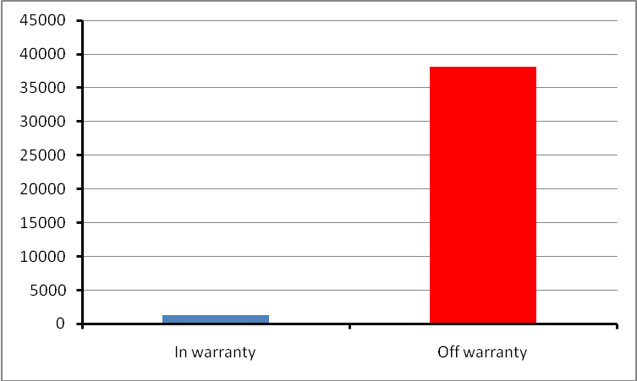
Figure 1. Total value of single repair in different workshops

To determine which of the two components to affect the repair most of the reliability of the test system is necessary to conduct a further examination of the quality of original and alternative parts. This study is carried out by the statistical survey of the value of failures and specifically cost of their removal per 1000km. After processing the experimental data were obtained absolute costs made ​​for labor and spare parts before the expiry of warranty period and after the warranty period (Figure 2, Figure 3).

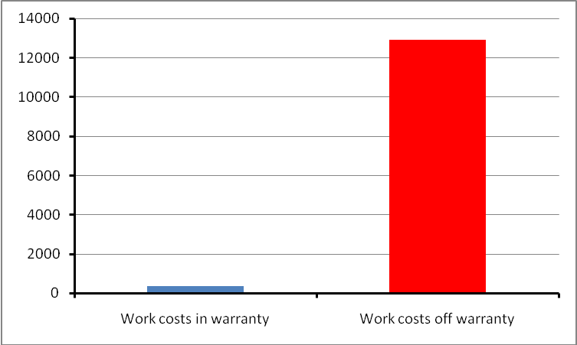
Fig. 2. The cost of labor during and after the warranty period

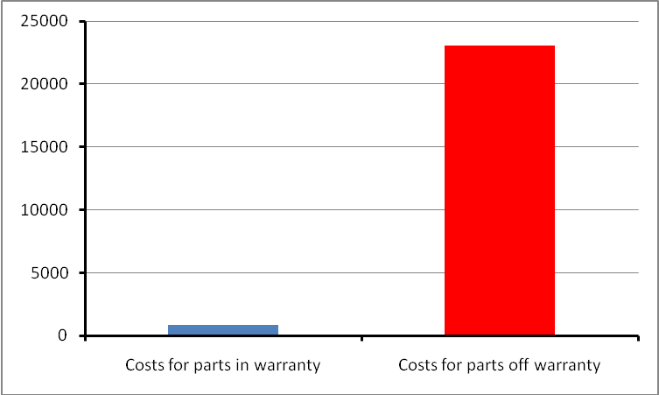
Fig. 3. The cost of spare parts during and after the warranty period

Despite the high value of the unit in the company's repair service, it appears that using brand service made ​​less costly to repair the chassis. Explanation is the poor quality of spare parts consumed after warranty. Since repair of chassis do not have to be applied the high-skilled workers and therefore this factor can be ignored.
The results of the specific costs incurred for maintaining the chassis during the operation of vehicles tested is shown in Figure 4.

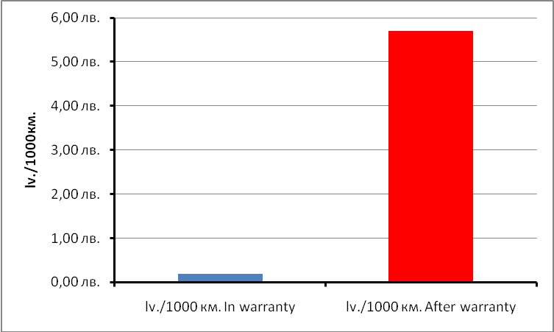
Fig. 4. Specific costs for 1000 km during and after the warranty period

The figure shows that despite the high cost of repair in a brand service is more profitable to maintain the fleet in special brand service as the company spent 0,19 lv./1000km. in the special brand service and 5.70lv./1000km. in non-specialized service.
An interesting question is, what part of the suspension has the highest specific value. The results of this study are shown in Figure 5.

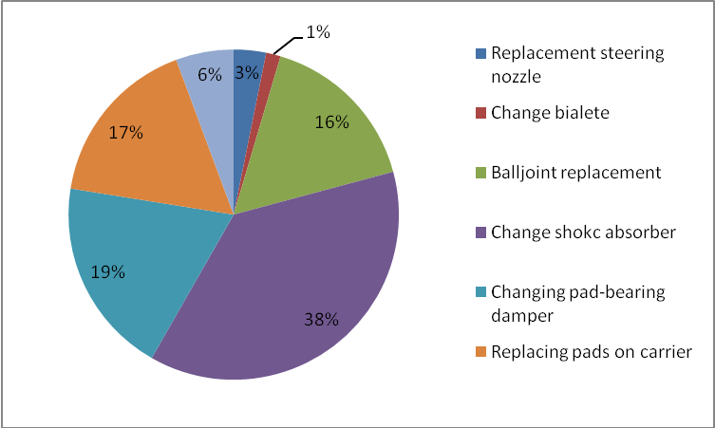
Fig. 5. Distribution of specific repair costs of individual parts in the suspension of 1000 km

Amounts spent to repair the individual details are given in Table 1.
The highest value of specific costs in suspension in studied cars is the costs for changing shock absorbers, followed by specific cost for changing pad-bearing damper.

Table 3.
Specific cost of the repairs in different parts of the vehicle chassis.

 | overal
Replacement steering nozzle | 0,19 lv./1000 km.
Change bialete | 0,08 lv. ./1000 km.
Balljoint replacement | 0,96 lv. ./1000 km.
Change shokc absorber | 2,20 lv. ./1000 km.
Changing pad-bearing damper | 1,13 lv. ./1000 km.
Replacing pads on carrier | 0,99 lv. ./1000 km.
Setting the front | 0,33 lv. ./1000 km.

Conclusion

As a result of the study can be derived following suggestions to optimize the cost of maintenance whiteout compromising reliability and safety of the vehicles:
- Repair of chassis can be made only at the specialized brand service;
- For additional saving, repairs of the chassis can be carry in non-specialized service, but using original parts.
Specific costs for maintaining vehicles in a brand dedicated to service more Low than in non-specialized service.
The highest value of specific system in suspension of studied cars are the costs for changing shock absorbers.

Reference

[1] Statistics on failures and cost of repairing them by company "Econt"
[2] STOYANOV Aleksandar, Orlin STOYANOV, Emil SAVEV, Toncho BALBUZANOV, ANALYSIS OF THE OPERATIONAL RELIABILITY OF ENGINES AND TRANSMISSIONS FOR VEHICLES WITH ELECTRONIC CONTROL SYSTEMS USING PARETO APPROACH, “Transport Problems 2011, Katowice Poland.
[3] Milchev M., Kolev N., COMPARATIVE STUDY OF THE RELIABILITY OF COMMERCIAL VEHICLES FROM DIFFERENT GENERATIONS, “Transport Problems 2011, Katowice Poland.

The study was supported by contract № BG051PO001-3.3.04/28, "Support for
the Scientific Staff Development in the Field of Engineering Research and
Innovation”. The project is funded with support from the Operational
Programme "Human Resources Development" 2007-2013, financed by the
European Social Fund of the European Union.

